**Step by Step Guide to GIT**

Git is a version-control system (i.e., a piece of software) that helps you keep track of your computer programs and files and the changes that are made to them over time

**Step 1: Create a GitHub account**

The easiest way to get started is to create an account on [GitHub.com](https://github.com/) (it's free).

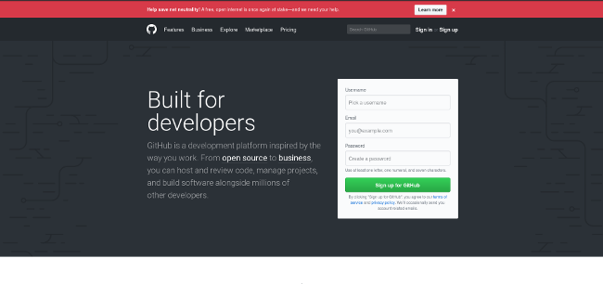

Pick a username (e.g., octocat123), enter your email address and a password, and click **Sign up for GitHub**. Once you are in, it will look something like this:

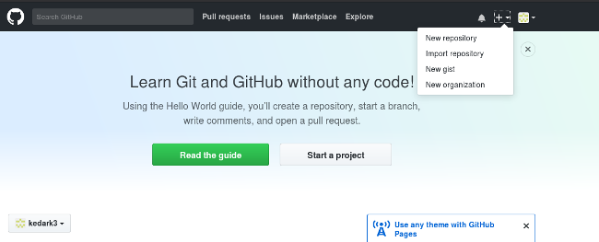

**Step 2: Create a new repository**

A repository is like a place or a container where something is stored; in this case we're creating a Git repository to store code. To create a new repository, select **New Repository** from the **+** sign dropdown menu (you can see I've selected it in the upper-right corner in the image above).

Enter a name for your repository (e.g, "Demo") and click **Create Repository**. Don't worry about changing any other options on this page.

Congratulations! You have set up your first repo on GitHub.com.

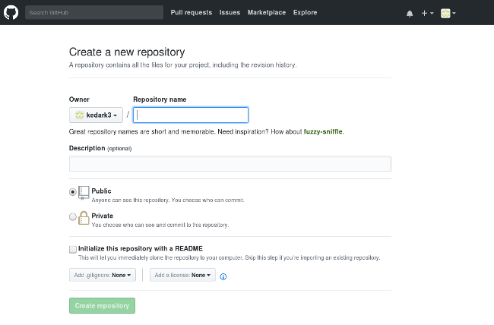

Step 3:

Lets create a folder named 'RCWALFS' and initialise a repository where we want our files to be tracked.Before Initialising the Repository ,right click anywhere and you should be able to see 'GIT Bash'.Click on the GIT Bash and it will take you to the command prompt where you issue the commands to do the tasks

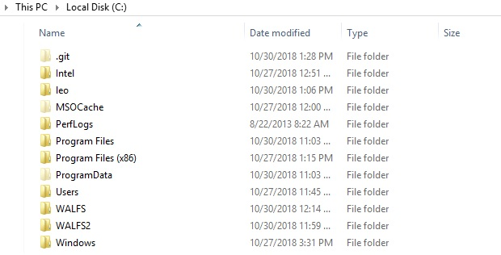

Step 3:

Check the present working directory by issuing the command 'pwd' on the command prompt.Current working directory as per the below image is C:\(Root Path)

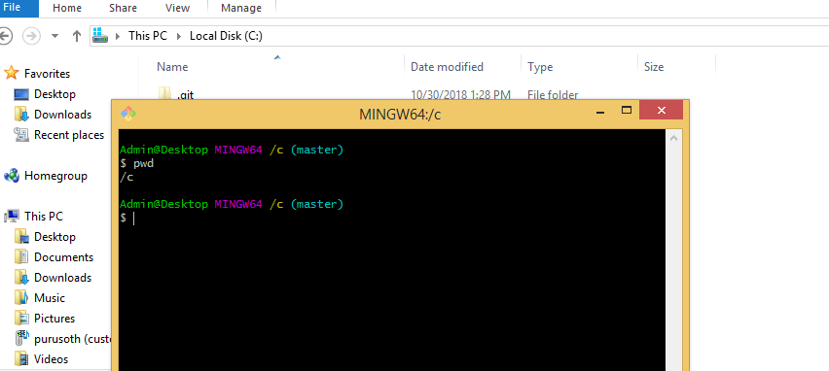

Step 4:

Now create and initialise a repository named 'RCWALFS'.After initialising the repo, you should be able to see a hidden file .git.If .git file is not found,no files can be tracked.

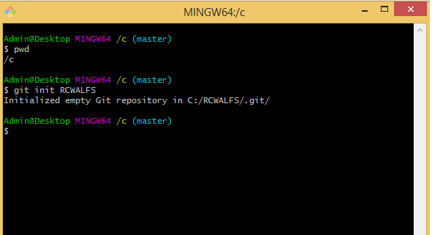

Step 5:

Now copy any file on the folder where .git is created.Let me create a word file and keep it in that folder

Name of the file is Test and it is going to be tracked

**git add** . adds all modified and new (untracked) files in the current directory and all subdirectories to the staging area (a.k.a. the index), thus preparing them to be included in the next **git** commit

*.*- It will track all the files in that folder.If you want to track only .doc files, you can issue the below command

git add *.doc

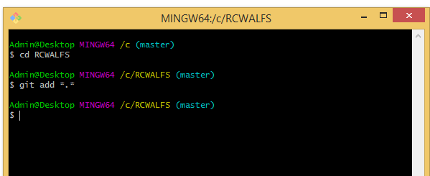

Step 6 :

Now it is time to commit the changes

The "**commit**" command is used to save your changes to the local repository

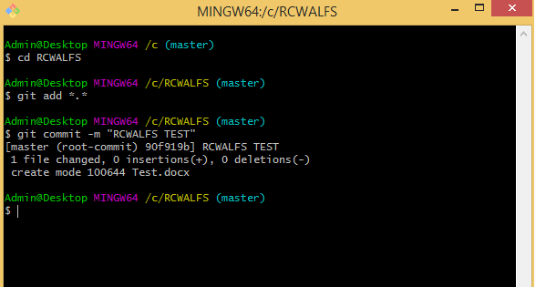

Step 6 :

Configuring the GIT for correct identity(username and password)

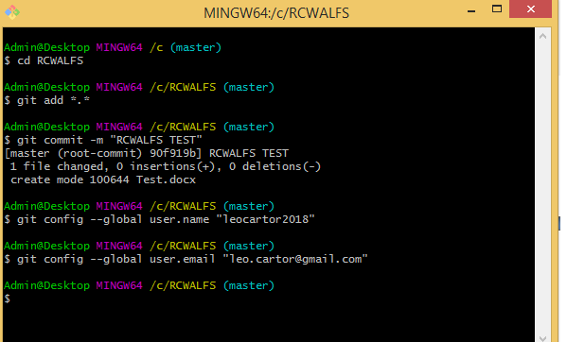

Step 7:

Now it's time to add the files from local repo to Online repo

To add a new remote, use the git remote add command on the terminal, in the directory your repository is stored at.

The git remote add command takes two arguments:

* A remote name, for example, origin
* A remote URL, for example, https://github.com/leocartor2018/RCWALFS.git

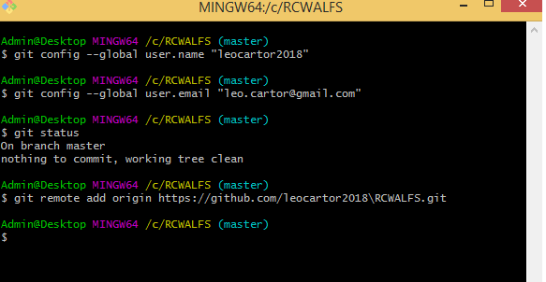

After issuing the command git remote add origin https://github.com/leocartor2018/RCWALFS.git

git push -u origin master

Ignore